Is Your Blackboard Course in Compliance? 8/1/07

Make sure your course menu has these as the first five items. To organize, remove or rename buttons go to Creating Consistency in the Course Content Menu - eliminate unnecessary items or add new ones (shock wave file format)

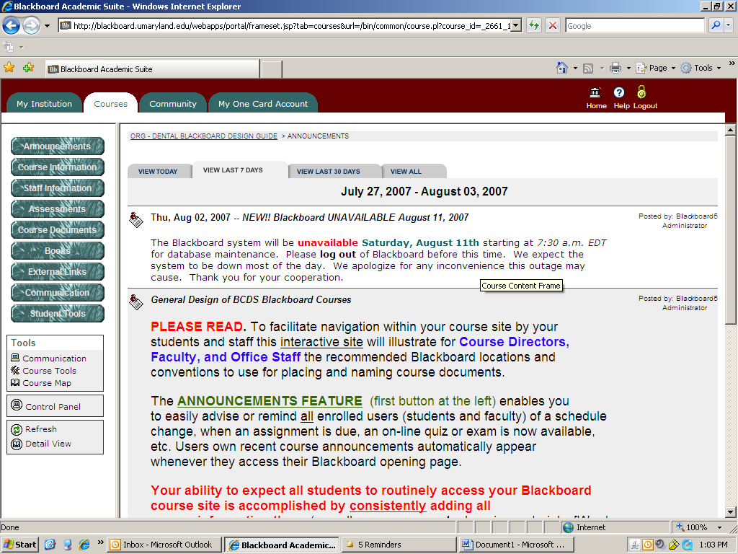

Under Course Information: do you have an up-to-date syllabus with complete information and competencies? Go to Course Syllabus for DDS - cut and paste version, save a copy and revise yearly. Do you have an up-to-date course schedule?

Under Staff Information: Have you included information so students can contact the Course Director or Course Faculty?

Under Assessments: Questionmark assessments will be loaded here along with Assignments you want to load and grade. This button is currently labeled Assignments, so you will have to change the name to Assessments. See Creating Consistency in the Course Content Menu - eliminate unnecessary items or add new ones (shock wave file format)

Under Course Documents: Do your folders for your lectures correspond to the titles given in your Course Schedule?

If you have completed the above, your Blackboard course should be in compliance. Don't forget to refer to this site for assistance. ORG - Dental Blackboard Design Guide

