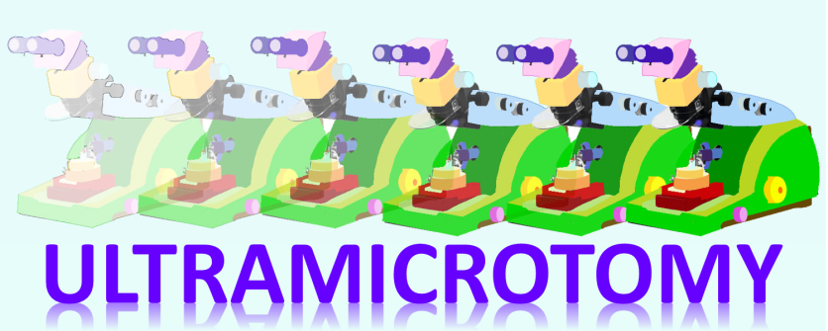
Cryo-ultramicrotomy Mini-Course
July 27th to 28th, 2015
Electron Microscopy Core Imaging Facility, University of Maryland, Baltimore,
Room 696 Howard Hall
Access via Bressler Research Building entrance located on 655 West Baltimore Street
Baltimore, MD 21201

Tentative Program

July 27th, Monday
9:00-10:00 Know your tools: ultramicrotomes and diamond knives
10:00-11:00 Cryo sectioning of sucrose infiltrated samples (Tokuyasu) & Cryo sectioning of frozen hydrated samples (CEMOVIS)
11:00-11:15 Break, Coffee & Tea
11:15-12:00 High pressure freezing and preparation of frozen hydrated cryo EM sample
12:00-13:00 Lunch break
13:00-14:30 Practical demonstration: High Pressure freezing
14:30-15:00 Break
15:00 -16:30 Practical demonstration: Tokuyasu and CEMOVIS sectioning

July 28th, Tuesday
9:00-16:30 Hands on practice rotation
Lunch break 12:00-1:00

Instructor:
Helmut Gnaegi : helmut.gnaegi@diatome.ch
Diatome Ltd,
P.O.Box CH-2501 Biel-Bienne
Switzerland
Tel: +41 32 332 91 13

